**Desktop:** The Desktop category is located below the Profile category on the main Settings menu panel, and is represented by an icon of a computer screen with “Desktop” displayed beneath it.  Clicking on the icon will allow you **to view and change your desktop settings.**

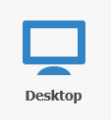

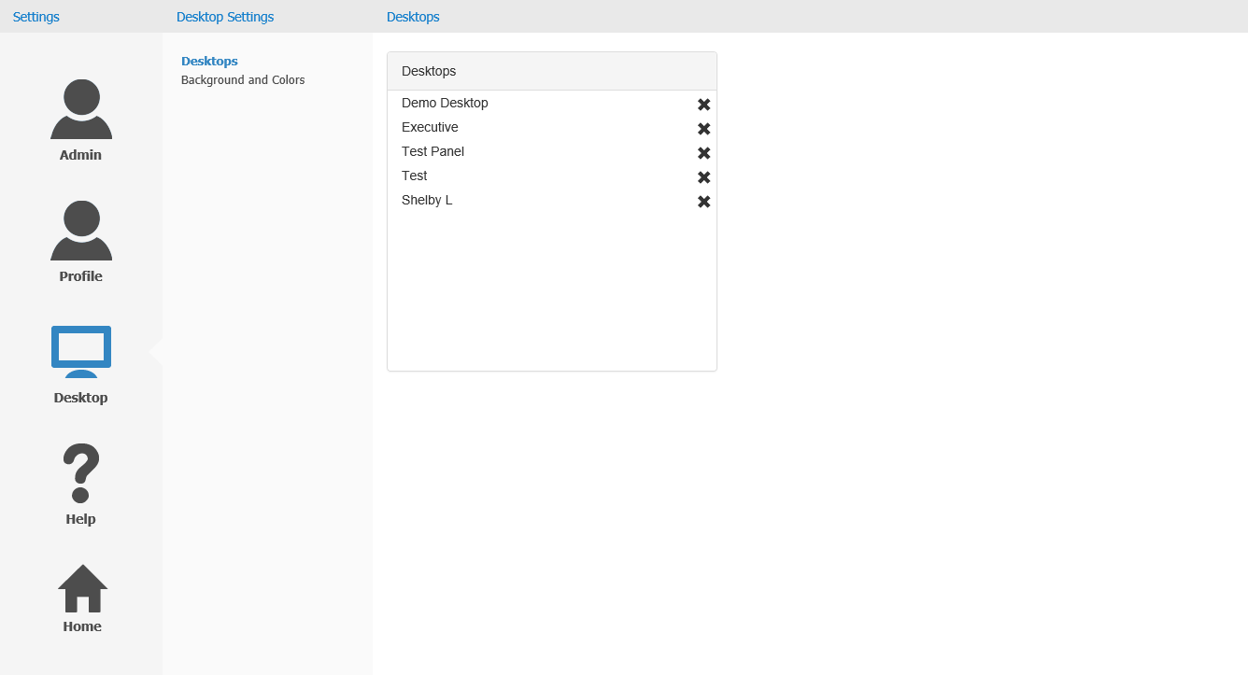

**Desktops:** The Desktops panel allows you to see a list of your current desktops, change the order the desktops appear in the program, and remove one or more desktops from the program.

Desktop Order: To change the order of your desktops:

* Click on one of the desktops.
* Drag it to its desired place in the new order while holding down the left mouse key.
* Release the mouse to drop it into its new position.  The desktops will then shift into the new order in the main program, with the Desktop Shortcuts changing to match.

Removing Desktops: To remove a desktop from the program using the Desktop Settings, click the “X” next to the desktop’s name in this panel.  The name will disappear, and the desktop will be removed from the program.

**Backgrounds and Colors:** The Backgrounds and Colors panel allows you to change the backgrounds on your individual NetView Desktop desktops.  This often helps you differentiate between desktops, or between store locations.

***TIP:*** To help distinguish between each location’s desktop, create **unique** backgrounds for each one.

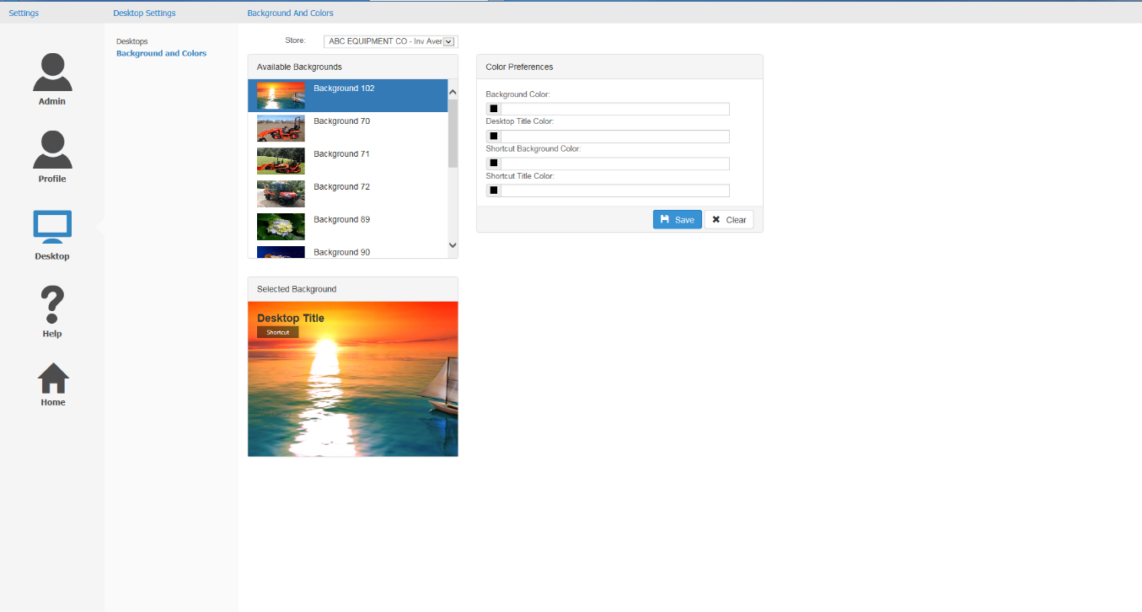

Store Select: This drop-down menu is located at the top of the panel.  Use it **to select the business location whose backgrounds you wish to view or edit**.

Available Backgrounds: This box is located beneath the Store Select bar.  It displays the background options available for you to use on your desktops.

* **To select a background for your desktop,** click on the desired option in this box.  It will highlight in blue, and should then be set as your background when you return to your desktop.
* **NOTE:** Only **a system administrator** can add or remove background options from the program.  **Regular Users must choose their backgrounds from the available options**.

Selected Background: This box is located below the Available Backgrounds box.  When you select a background in the Available Backgrounds box, a magnified version of the image will appear in this box.

Color Preferences: This feature is no longer available.